Digital Audio Workstation
CMSC490- Senior Project I
Fall 2025

Project Requirements
10/3/2025

Instructor Comments/Evaluation
89
Overall a good project requirement that follows the required outline
Nice sections of “Objectives” and “non-functional requirement”. Good lists of glossary item and references were included.

User cases need improvements.
User-case description needs improvement (need to describe each user case)
Functional requirements could be improved (e.g, specified as Input/Output)
Missing in-text citations
Please see detailed comments inside.

Table of Contents
Abstract --------------------------------------------------------------------------------------------------------1
Introduction----------------------------------------------------------------------------------------------------1
Background-------------------------------------------------------------------------------------------1
Objective Overview of Project---------------------------------------------------------------------2
Team dynamics/details------------------------------------------------------------------------------2
Application Domain------------------------------------------------------------------------------------------3
Project Context---------------------------------------------------------------------------------------4
Initial Business Model----------------------------------------------------------------------------------------4
Operational Environment----------------------------------------------------------------------------4
Description of Data Services-----------------------------------------------------------------------5
Use Case of UML Diagram------------------------------------------------------------------------6
Initial Requirements------------------------------------------------------------------------------------------6
Functional--------------------------------------------------------------------------------------------6
Non-functional--------------------------------------------------------------------------------------7
Documentation--------------------------------------------------------------------------------------8
Testing/Revisions-------------------------------------------------------------------------------------------9
Citations-----------------------------------------------------------------------------------------------------9
Appendix: Glossary---------------------------------------------------------------------------------------10
Appendix: Team Details---------------------------------------------------------------------------------12
Appendix: Workflow Authentification----------------------------------------------------------------13
Appendix: Report from Writing Center---------------------------------------------------------------14

Abstract
The Digital Audio Workstation (DAW) is intended to help musical artists and composers by providing software to create music using different synthetic instruments and individual tracks for each instrument that can be stacked to play at the same time which are saved as MIDI files that can also be imported into the program for editing. While many existing DAWs provide these features, they tend to be very complex and complicated to use and are expensive for individuals. Existing DAWs are usually very complex and complicated software which takes a lot of time simply to learn and understand all the functions they provide while also having prices in the range of $100-$600. The team aims to provide these common features while providing a much more affordable, user-friendly, and easily available option. The creation of this software will provide a lower barrier to entry for amateur and professional music creation.
Introduction
Background
DAWs are an important element in music creation due to their ability to allow musicians and composers to edit and synthesize music by manipulating audio files and MIDI files to add onto, remove, or create them. In addition, they can allow the direct creation of music through sounds inside the software, called MIDI instruments, or using MIDI peripherals to help the creative process even more. Without them, composing digital music would be incredibly difficult and the creation of music for media such as games, movies, and shows would be much harder. DAWs are an incredibly important tool that allows for music to be used in many more contexts than musicians playing their instruments live or simply recording with no proper sound/audio mixing.
Objective of project
The Objective of our DAW is to create a user-friendly, affordable, and highly compatible software. This will create a comfortable and easy to use space for musicians and composers while having a low learning curve to get the most out of the software. It will include compatibility with MIDI peripherals, audio files and recordings, and proper usage of file systems for exporting and importing files from the software. This will all be achieved through the use of the coding language C++ as the backbone of the program, MySQL for formatting the file systems, pre-existing libraries for MIDI instruments, audio recordings, and MIDI peripherals. To make the program easy to learn and user-friendly, we plan to include tutorials throughout the program that can be found simply by hovering over buttons or settings while also designing the software from the perspective of a user who knows nothing of these programs. The program will be made affordable because we will not be charging for it and the source code will be made open source. Through both the use of an open-source design model, as well as having the source files coded in C++, the program will be widely accessible on a variety of machines.
Team detail and dynamics
This project requires a team that is well suited to its design and development due to its complexity, which this team can offer. It is crucial that members do separate but equal jobs throughout the different segments of the project to allow the project to be finished within a realistic time frame. The jobs have been divided up based on individuals’ skills, comfort, and wants. Each member will be heading a different document and segment of the design while being supported by the other two members throughout the entirety of the process. This will be the best way to support our goal of attempting to make the best product out of our skills that we can achieve, regardless of the difficulty. This work division will also put a lot of responsibilities on the respective leaders of each segment, but will allow for us to adjust and address any issues that come up as we work, and make sure we can overcome these issues.
Team members | Major | Segment Leader
Clayton Sanner | CS | Requirements and Analysis
Brandon Smith | CS | Implementation and User Manual
Alice Bruce | CS | Design

The project team will need to be able to easily and efficiently communicate with each other and provide changes to files at any given time. To accomplish this, a Discord server was created to provide a place for communications and meetings. In addition, a GitHub repository will be created to maintain and control our programs file structure that all team members will have access to.

Application domain
Project context
The main goal in creating this DAW is to provide an easily accessible and user-friendly option for anyone interested in digital music or composing in general. Generally speaking, DAWs tend to be an expensive type of non-commercial software, the popular options range anywhere from $100 at the lower level to up to nearly $600 for the high-end software. This barrier of entry could very likely be a roadblock for anyone who wants to try their hand at composing digital music. On top of that, the free options that do exist, such as Audacity, do not provide the functionality necessary for composing music. And in both cases, those DAWs are quite complicated, often essentially requiring users to watch tutorials online in order to use them efficiently. Creating a DAW that is cheap, easy to use, and adequately functional is our reasoning for taking on this project.
Initial Business model
Operational environment
This DAW will be designed first and foremost to be accessible and friendly to anyone who wishes to create or edit music, voice overs, or any other sort of audio. As such, this software will be designed with more casual, non-commercial use as a priority. While it will still be built with professionalism and complexity in mind, the goal of this workstation is to streamline the process of music and audio editing in order to make the field less intimidating to begin learning and experimenting with. Editing software such as this tends to be either too complex for beginner use, too expensive to just casually try out, or both. As such, this workstation aims to offer the essentials an editing software will need, and attempt to peel back as many layers of the complex performance that is audio editing as possible, as to offer what will hopefully be the beginner’s choice for a Digital Audio Workstation at a much more affordable price.
Description of data sources
An editing software such as this typically works by having the program open files that you direct it to and making them accessible to be placed on a timeline. This workstation will follow as such, as it will be designed to open a folder designated by the user and place the files it can interact with on a timeline automatically. It will require further input from the user to organize said files. This software will be able to open MIDI files for the purposes of changing them in the editor, and will open audio files for prerecorded audio.
In addition to opening already existing files, this workstation will allow users to create new files of the same types that it can open and place them on a timeline for editing purposes accordingly. Creating music as MIDI tracks will be possible by creating and saving MIDI files, and the software will save specific project details, such as the MIDI instruments assigned to each MIDI track, separately, in accordance to what the user has told the program to open for the project. In specific, details such as this will be saved in a configuration file created inside the project folder the user has chosen to open, given the same name as the project the user has created. Designing user projects as such will streamline the editing process and keep every detail about the project organized in the same location and easily accessible to the user.
Use case UML diagrams
The Digital Audio Workstation will have users either import data from pre-existing audio files or they will make new recordings inside of the program. They will be able to edit, mix, and control the playback aspects of the audio. The use of the DAW is almost completely driven by the user’s input. This driving input is what allows the program to perform any job, as it is a tool that assists in the creation of music and has to be controlled by the user for different circumstances.
Use Case UML Diagram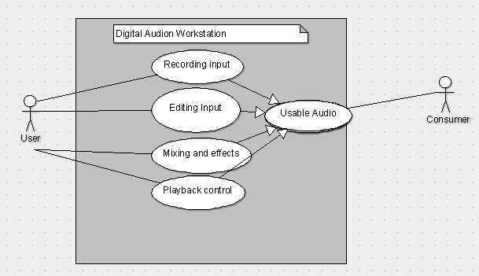
Figure1. Use case UML for the features available to the user. The user will need to be able to manipulate the audio in anyway they see fit to provide usable audio to any given consumer be that for individuals projects, movies, tv show, or games
Initial Requirements
Functional
A DAW has multiple features that are necessary for functional usage. The most basic description of these features are as follows. A DAW needs to visually display MIDI files which will be split into multiple MIDI tracks (if it has any) which will be stacked on a timeline. These MIDI tracks can be opened in an editor to allow for the user to add, remove, and edit the MIDI events contained within. It needs to have the ability to open existing MIDI files as well as allow the user to create new MIDI tracks that will be placed on the timeline. It needs to have the ability to record audio via a microphone which will also be placed on the timeline, as well as allowing for existing audio files to be opened. It needs to have the ability to play everything currently on the timeline at any given moment, including both audio files and MIDI tracks. The software will be able to save all tracks into a project, which the user will be able to open at a later time to continue work to work on. It will also be able to export all tracks into a single audio file. Lastly, the software will be able to interface with a MIDI peripheral for additional functionality.
Non functional
Due to the single user nature of DAWs, a software like this does not have many non-functional requirements. The only requirements under this category are simplicity and user-friendliness, and low-latency audio playback. Simplicity and user-friendliness is important because it ensures that the software is easier to use than its competitors, which is a major selling point for this DAW. Low-latency audio playback is also important because while a project is still being worked on, and a user wants to listen to what they’ve done so far, all tracks on the timeline need to be played in sync with one another. If any track takes longer to start playing than another, the music will sound off and won’t be an accurate representation of what the current project should sound like.
Documentation
- Proposal Document
The initial document outlining and detailing the project idea
- Requirements Document
The document that communicates the overarching vision of the project and establishes a plan to follow for the rest of the project
- Specification Document
A Document that will detail the design, testing, and functionality of the DAW
- Design Document
Document that will detail the plan of how the project will actually be built from a coding perspective based on our requirements and specifications
- Project Log
A document that will provide information about the project throughout the development detailing progress, activities, issues and its lifecycle
- User Manual
A document that will provide information and educate a given user on technical information related to the project.
Testing/Revisions
This document was created through a collaborative effort of the group members. It was shared online allowing each member to edit and change the document as was needed. Revisions were saved locally and through a discord server to provide access to previous versions of the document. For our program, the team will be using GitHub Desktop, which will allow team members to share revisions with the group while also keeping documentation of our previous versions of the program if rollbacks become necessary, which can help to negate negative effects of problems posed later in the program’s lifecycle that could keep the team from being able to continue progress. Testing of the program will be done by each member on their respective hardware as well as a third-party volunteer that the team will be recruiting to help debug and test the code in ways that individual team members who are too familiar with the code would not be able to.
Citations
- Create your best music | FL Studio. (n.d.). https://www.image-line.com/
- Creative tools for music makers | Ableton. (n.d.). https://www.ableton.com/en/
- javidx9. (2020, March 8). Programming MIDI [Video]. YouTube. https://www.youtube.com/watch?v=040BKtnDdg0
Appendix: Glossary
MIDI track - a collection of MIDI events assigned to a single MIDI instrument that will “play” those MIDI events
Timeline - An area of the UI where MIDI tracks are displayed simultaneously
MIDI event - a section of a midi file that contains a note, the MIDI instrument that plays that note, the velocity of that note, and the amount of time between that note and the previous note
Time signature - A fraction value that represents the number of beats in a measure (top number) and what division/subdivision the measure is counted in (bottom number). Example: The time signature 3/4 will have three beats and the length of each beat will be a quarter note. The time signature 7/8 will have seven beats and the length of each beat will be an eighth note.
Velocity - The volume of a midi event, an integer in the range 0-127
MIDI instrument - A virtual instrument that reads MIDI events and plays sounds at the pitch, velocity, and timing defined by the MIDI events using a sound type specific to the MIDI instrument
MIDI peripheral - A physical instrument that has digital capabilities
MIDI file - A file that contains one or more MIDI tracks
Measure - A grouping of beats, of which the number of beats is defined by the time signature
Beat - a single segment of a measure
Note - a sound of a certain division/subdivision that has a pitch. A note is named by its pitch. This can be any one of the following, starting from the lowest pitch to the highest pitch: C, C#/Db, D, D#/Eb, E, F, F#/Gb, G, G#/Ab, A, A#/Bb, B. This letter is followed by a number that determines the octave.
Semitone - The figurative distance between two adjacent notes in terms of pitch. For example, the difference between E and F is one semitone, and the distance between G and A is two semitones as the note G#/Ab is between G and A
Sharp - a note is sharp if it is one semitone higher than the root letter. This is denoted by the # symbol. For example, a note that is one semitone higher than A would be A#
Flat - a note is flat if it is one semitone lower than the root letter. This is denoted by the letter ‘b’, lowercase is required. For example, a note that is one semitone lower than A would be Ab
Octave - a grouping of one of each of the 12 notes, starting at C, that increases sequentially until it ends at B. The higher the number of the octave, the higher the pitch of the notes in said octave are.
Division/subdivision - The length of a note measured in beats. This starts at a whole note (4 quarter notes), then can be divided by 2 sequentially to create shorter notes that are half the length of the next largest note. Whole note, half note, quarter note, eighth note, etc.
Tempo - The speed of the music, measured in beats per minute (BPM)
Project - The complete collection of MIDI files and audio files that are currently open on the timeline
Project folder - A folder that is saved onto the system in which the software is running that holds all files associated with a project
Editor - A function of the program that will allow MIDI files to be edited by adding, removing, moving, and/or changing velocity of MIDI events in a track.
Configuration file - A file containing any additional information about the project that is not included in the MIDI and audio files contained in the project folder
DAW (Digital audio workstation) - A software that allows for the creation of digital music and audio
Appendix: Team Details
This document was written in cooperation with all team members over the course of three weeks, it was a team effort under the leadership of Clayton Sanner. Contributors are outlined as such based on the sections they contributed to the most
- Alice Bruce was a major contributor to the “introduction”, “application domain”, and the “Testing/Revision” segments of the document
- Brandon Smith was a major contributor to the “abstract”, “initial business model” and “initial requirements” segments of the document
All other major sections of this document were developed during formal and informal meetings where the members contributed equally. In these meeting group members would provide assistance to each other and constructive criticism to help with the creation of the document. Proofreading was done as a group effort to provide the most grammatically correct and soundly formatted document. Figures were also done as a group effort with the decision to use them being unanimous. The team also was provided with assistance from a meeting with the writing center to provide feedback. Development on this project and the documents that will support it will continue as was detailed throughout this document
Appendix: Workflow Authentication
I, Clayton Sanner; Agree with the details defined in this document that as well as future work involving this project was done as stated per the description of this document
Signature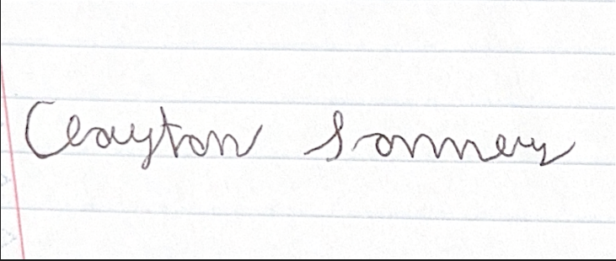10/17/2025
I, Brandon Smith; Agree with the details defined in this document that as well as future work involving this project was done as stated per the description of this document
Signature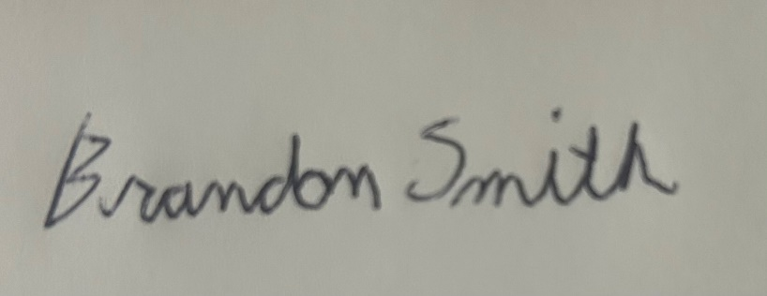10/17/2025
I, Alice Bruce; Agree with the details defined in this document that as well as future work involving this project was done as stated per the description of this document
Signature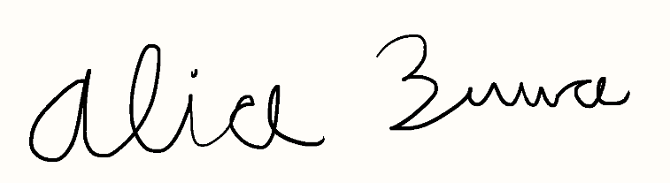10/17/2025

Appendix: Report from Writing Center
The overall paper seems to be fine. I found no glaring issues that I haven’t been told would be fixed, and otherwise found this to be as good spelling and formatting wise as I could.
-Foundry Writing Center Consultant

